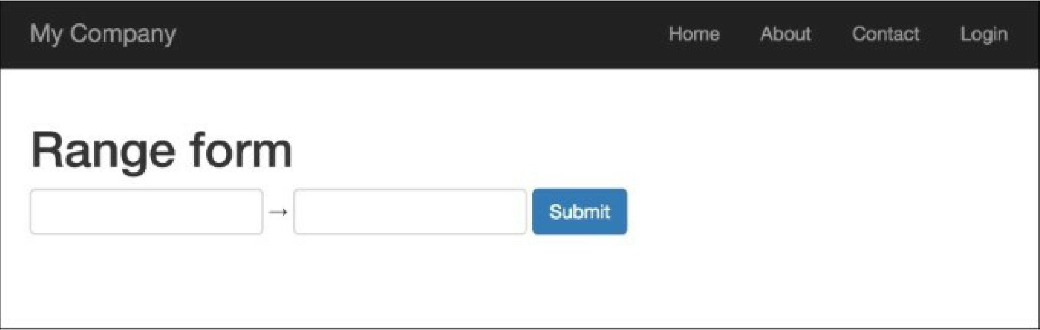

6. Enter 200 in the first text input field and 300 in the second, and you’ll get the following:

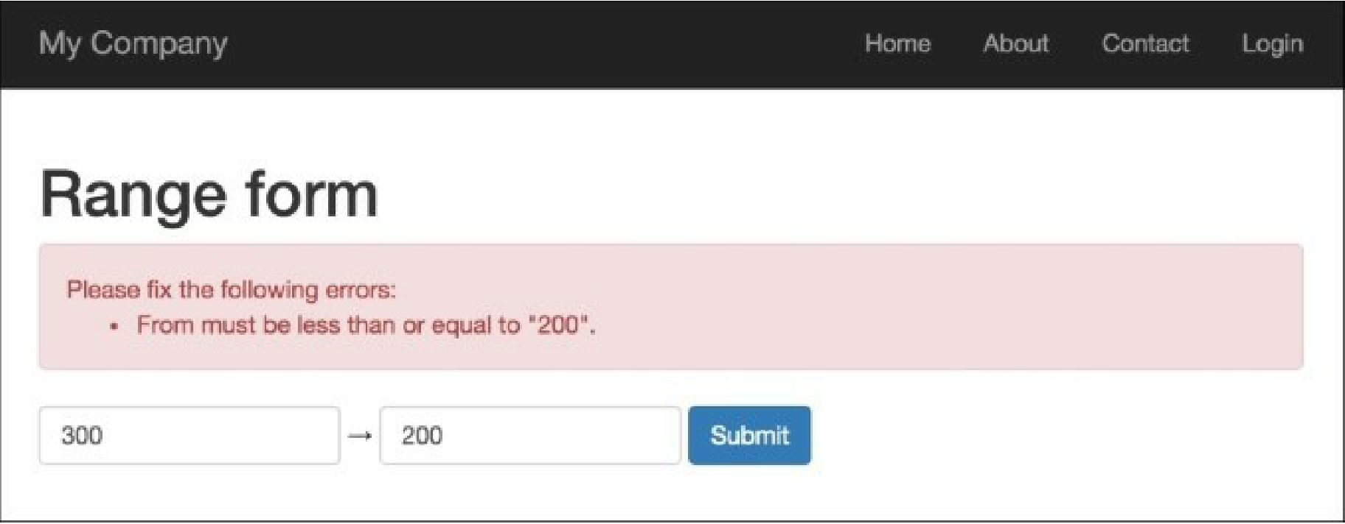

7. The widget outputs an error if the first value is bigger than the second; that is it. Try to input correct values, 100 and 200, for the first and second inputs, respectively: